**MAWLANA BHASHANI SCIENCE AND TECHNOLOGY UNIVERSITY**

**SANTOSH, TANGAIL-1902**



**DEPARTMENT OF INFORMATION AND COMMUNICATION TECHNOLOGY**

**Lab Report No: 01**

**Course Title:** Communication Engineering Lab

**Course Code:** ICT-2206

**Lab Report on:** Amplitude Modulation and Demodulation

|  |  |
| --- | --- |
| **Submitted By** | **Submitted To** |
| **Name: Kuldip Saha Mugdha**  **ID: IT-22018**  **2nd Year, 2nd Semester**  **Session: 2021-2022**  **Dept. of ICT, MBSTU** | **Dr. Monir Morshed**  **Professor**  **Department of Information and Communication Technology**  **Mawlana Bhashani Science and Technology University** |

**Date of Performance: 08/03/2025 Date of Submission: 12/03/2025**

**Introduction:**

Amplitude Modulation (AM) is a type of modulation where the amplitude is varying with respect to the carrier signal. Here, the carrier frequency is much higher than the modulating signal and information is contained in its amplitude variation. The frequency of the carrier remains constant. AM is used in radio and TV broadcasting applications.

**Equipment:**

1.Signal Generator

2.Oscilloscope

3.Power supply

4.Cable

5.MATLAB

6.Power Generator

**Theory:**The following equation represents the Amplitude Modulation:



where Ac and Am are the carrier and message signal amplitudes respectively. Demodulation recovers the message signal using special techniques like envelope detection.

**Procedure:**

**1.Generate message and carrier signals:**

* Set the carrier frequency fc to 1000 Hz
* Set the message signal frequency fm to 100 Hz
* Set the message amplitude Am to 0.5 and carrier amplitude Ac to 1
* Define the duration of the signal and sampling frequency

**2.Amplitude Modulation:**

* Use the formula of AM to generate the modulating signal

**3.Amplitude Demodulation:**

* Apply envelope detection to recover the message signal using Hilbert function in MATLAB which extracts the envelope of message signal

**4.Plot results:**

* Plot message signal,modulated AM signal and demodulated signal to visualize the process

**5.Analysis:**

* Compare the original message signal and the demodulated signal to check the effectiveness of the demodulation process.

**MATLAB code:**

% Amplitude Modulation and Demodulation in MATLAB

% Parameters

Fs = 10000; % Sampling frequency (Hz)

Fc = 1000; % Carrier frequency (Hz)

Fm = 100; % Message signal frequency (Hz)

Ac = 1; % Carrier amplitude

Am = 0.5; % Message amplitude

T = 1; % Signal duration (seconds)

t = 0:1/Fs:T-1/Fs; % Time vector

% Message signal (m(t))

message_signal = Am * cos(2 * pi * Fm * t);

% Carrier signal (c(t))

carrier_signal = Ac * cos(2 * pi * Fc * t);

% Amplitude Modulation (AM)

modulated_signal = (Ac + message_signal) .* carrier_signal;

% Envelope detection for demodulation

demodulated_signal = abs(hilbert(modulated_signal)); % Envelope extraction

% Plotting results

figure;

subplot(3,1,1);

plot(t, message_signal);

title('Message Signal (m(t))');

xlabel('Time (s)');

ylabel('Amplitude');

subplot(3,1,2);

plot(t, modulated_signal);

title('Modulated Signal (AM)');

xlabel('Time (s)');

ylabel('Amplitude');

subplot(3,1,3);

plot(t, demodulated_signal);

title('Demodulated Signal (Envelope Detection)');

xlabel('Time (s)');

ylabel('Amplitude');

% Play sound of the message signal

sound(message_signal, Fs);

**Output:**

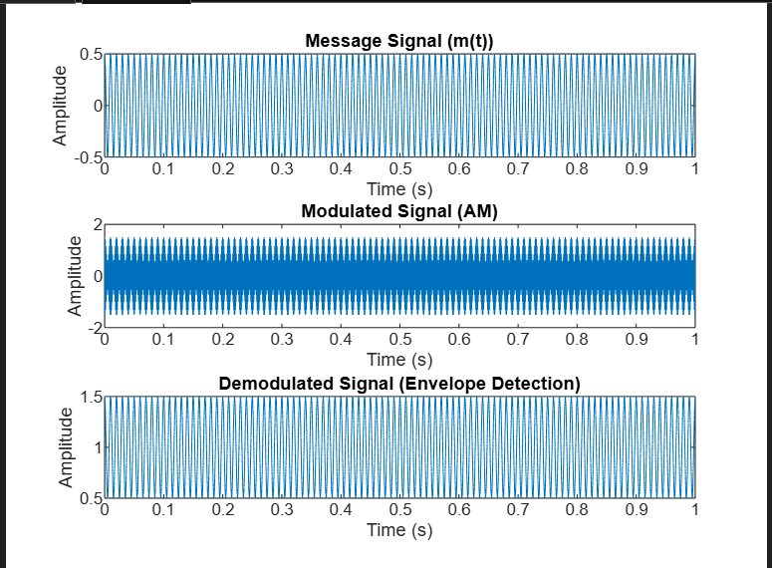

**Discussion:**

This experiment successfully demonstrated the process of amplitude modulation and demodulation. We generated an AM signal, transmitted it, and successfully demodulated it to recover the original message. The MATLAB code provided a simple yet effective simulation of the AM system, illustrating how modulation affects signal transmission and how the message can be recovered using envelope detection.